Project Design Phase-II
Data Flow Diagram & User Stories
Date | 14 June 2026
Team ID | [Enter Team ID]
Project Name | ShopEZ - Full Stack E-Commerce Platform
Maximum Marks | 4 Marks

Data Flow Diagrams
A Data Flow Diagram (DFD) is a visual representation of how information moves within a system. For the ShopEZ MERN e-commerce project, the DFD shows how customers, administrators, React frontend screens, Express.js APIs and MongoDB collections interact to complete shopping, cart, checkout and order management operations.

DFD Level 0 - Context Diagram
The Level 0 DFD represents ShopEZ as one complete system and shows the major external entities and data flows.
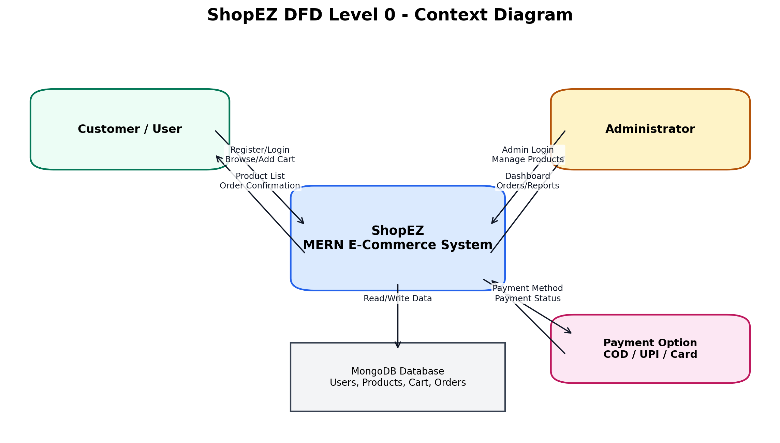
Level 0 Explanation:
External Entity / Store | Input to ShopEZ | Output from ShopEZ
Customer / User | Registration details, login credentials, product requests, cart updates, delivery details and payment method. | Product list, product details, cart summary, order confirmation and profile/order information.
Administrator | Admin login credentials, product create/delete requests and order viewing requests. | Admin dashboard, product management status and order reports.
MongoDB Database | User, product, cart and order data written by the backend APIs. | Stored users, products, cart items and orders returned to the application.

DFD Level 1 - Main Processes
The Level 1 DFD expands the ShopEZ system into the main processes used in the project: authentication, product catalog, cart management, checkout and admin management.
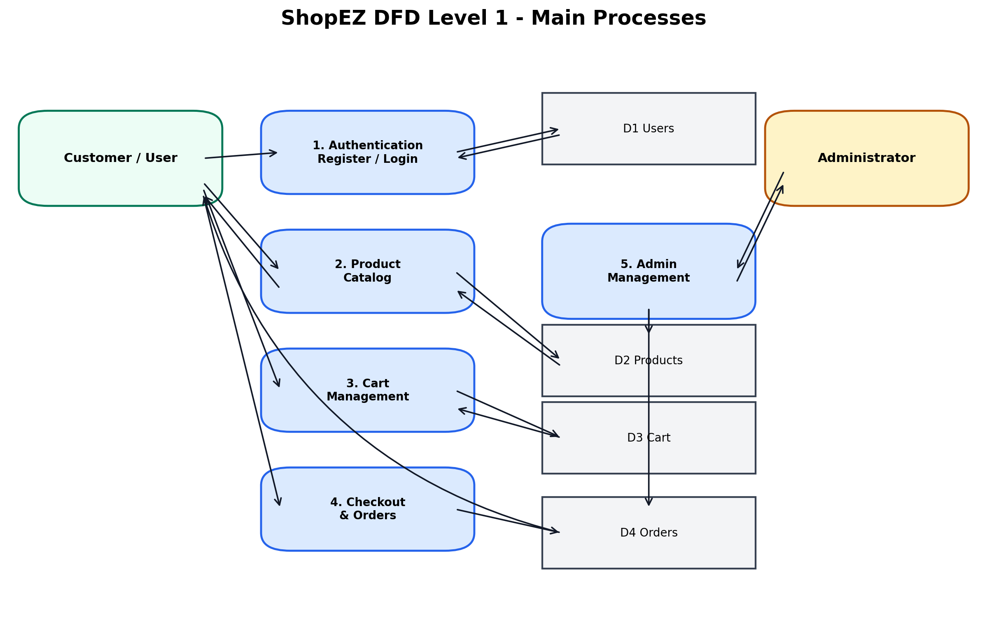
Main Processes:
Process | Description | MongoDB Collection / Data Store
1. Authentication | Handles user registration, login, JWT generation and role-based access. | Users
2. Product Catalog | Displays all products and product details to users. | Products
3. Cart Management | Allows logged-in users to add products, update quantity and remove items. | Cart
4. Checkout & Orders | Collects delivery details, calculates totals and places orders. | Orders
5. Admin Management | Allows admin to access dashboard, manage products and view orders. | Products, Orders, Users

User Stories
The following user stories describe the functional requirements for the ShopEZ e-commerce application.

User Stories Table - ShopEZ
User Type | Functional Requirement (Epic) | User Story Number | User Story / Task | Acceptance Criteria | Priority | Release
Guest / Customer | Registration | USN-1 | As a new user, I can register by entering username, email and password. | User account is created successfully and stored in MongoDB. | High | Sprint-1
Customer | Login | USN-2 | As a user, I can login using email and password. | Valid credentials generate a JWT token and the user can access profile, cart and checkout. | High | Sprint-1
Customer | View Products | USN-3 | As a user, I can view all products available in ShopEZ. | Products are displayed with image, title, description and price. | High | Sprint-1
Customer | Product Details | USN-4 | As a user, I can open a product details page before adding a product to cart. | The page displays product image, details, price, Add to Cart and Go to Cart buttons. | Medium | Sprint-1
Customer | Add to Cart | USN-5 | As a logged-in user, I can add products to my cart. | If the user is not logged in, the system redirects to login; if logged in, the item is added to cart. | High | Sprint-1
Customer | Cart Management | USN-6 | As a user, I can increase quantity, decrease quantity and remove products from my cart. | Cart quantity and price details update immediately. | High | Sprint-1
Customer | Checkout | USN-7 | As a user, I can proceed to checkout and enter delivery details. | Checkout form accepts name, mobile, email, address, city, pincode and payment method. | High | Sprint-2
Customer | Order Summary | USN-8 | As a user, I can view subtotal, GST, delivery charges and grand total before placing the order. | The checkout page correctly displays subtotal, GST, delivery charges and grand total. | High | Sprint-2
Customer | Place Order | USN-9 | As a user, I can place an order after filling the checkout form. | Order is saved and the user receives an order placed confirmation. | High | Sprint-2
Customer | Profile | USN-10 | As a logged-in user, I can view my profile details. | Profile page displays username, email and role. | Medium | Sprint-2
Administrator | Admin Login | USN-11 | As an admin, I can login and access the admin dashboard. | Only users with admin role can open the admin dashboard. | High | Sprint-1
Administrator | Product Management | USN-12 | As an admin, I can add and delete products. | Product data is created or deleted from MongoDB and the products page updates. | High | Sprint-2
Administrator | Order Management | USN-13 | As an admin, I can view all orders placed by customers. | Admin can view order details from the protected order API. | Medium | Sprint-2
Note: Current implementation supports JWT-based login, product listing, product details, cart operations, checkout form with GST/delivery/grand total, and admin product/order management. Future enhancements can include online payment gateway integration, email confirmation, wishlist and product reviews.

